1. 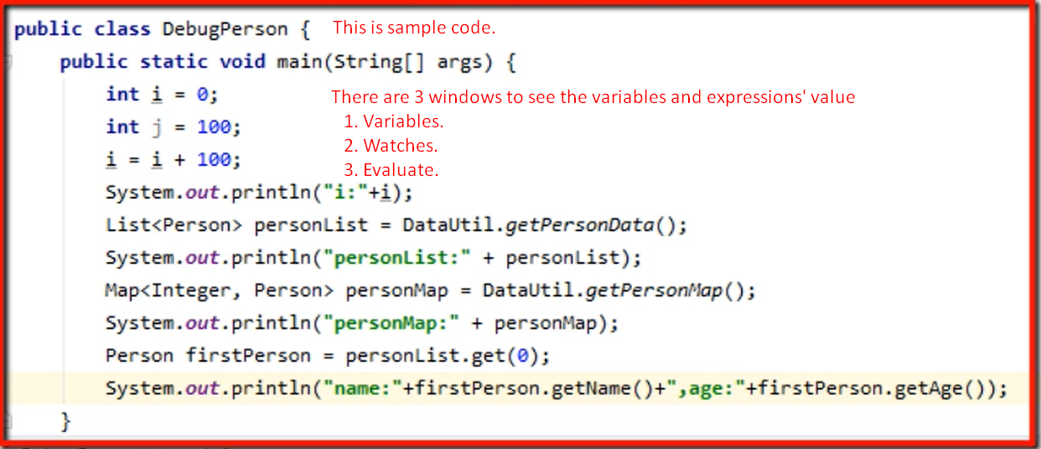
2. 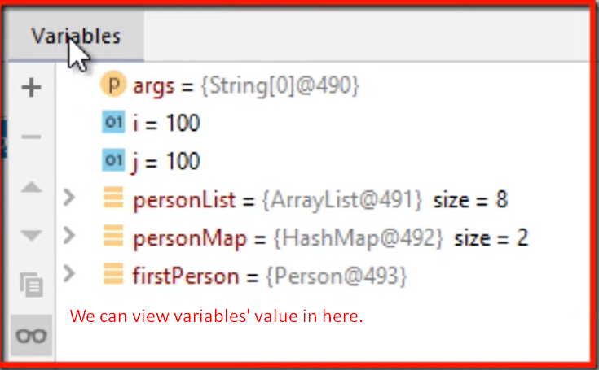
3. There could be scenario where we need to track more complex expressions which are not part of the program.
4. **Solution**: Watche Section  
   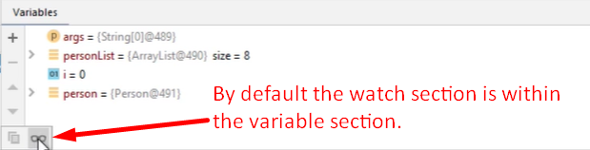
5. 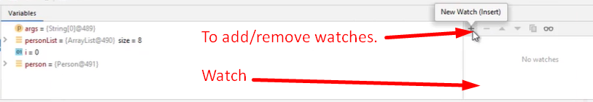
6. 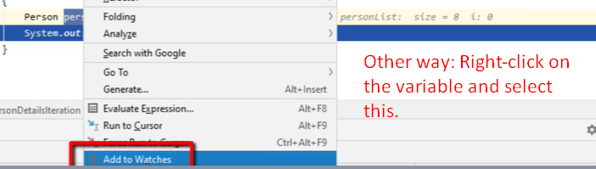
7. 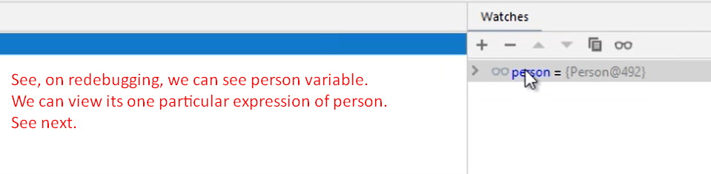
8. 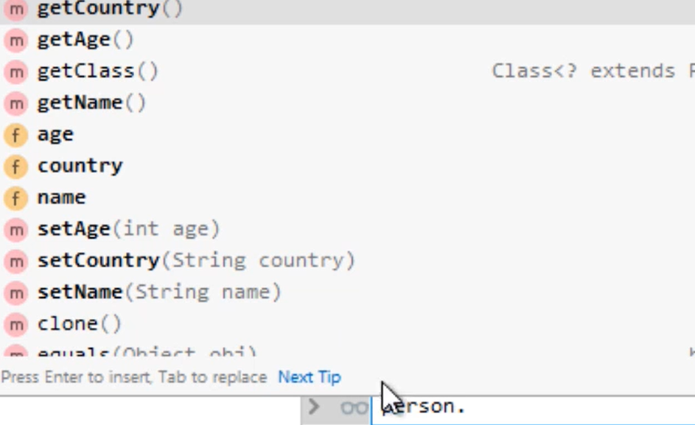
9. 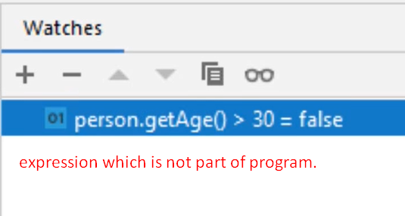

Evaluate Expression

1. To evaluate any expressions.
2. 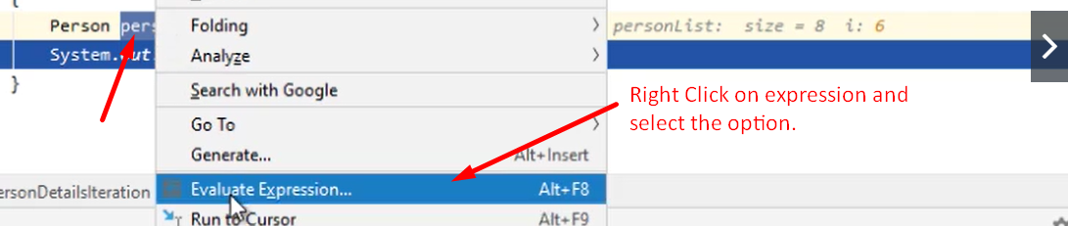
3. 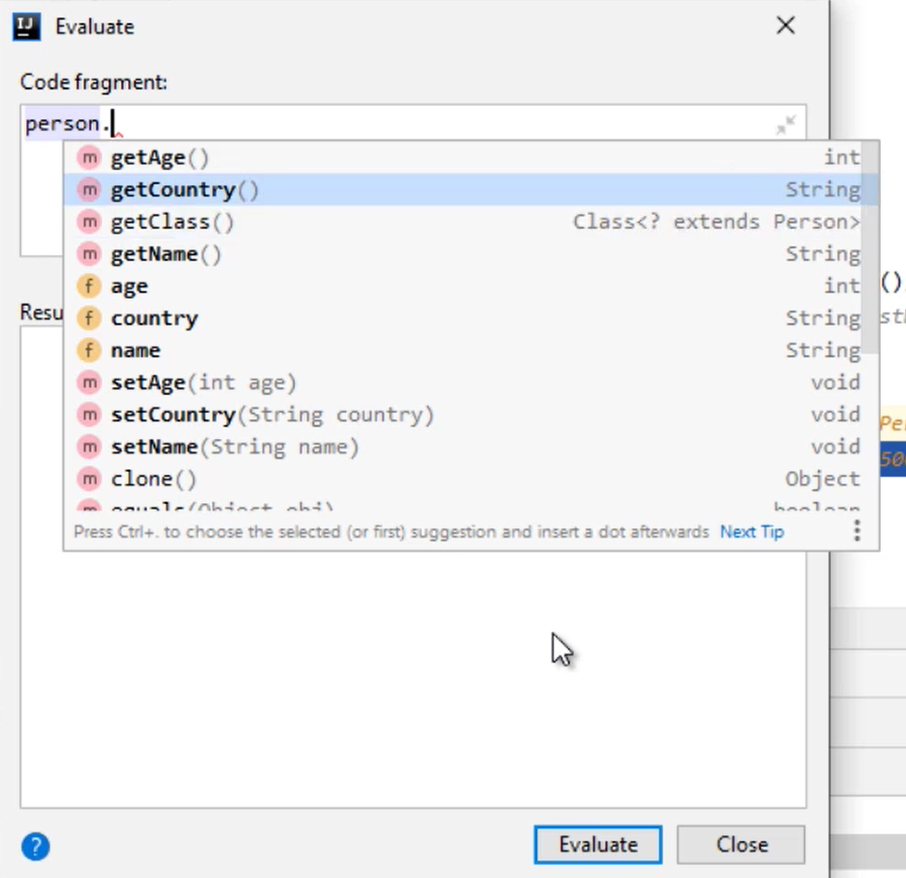
4. 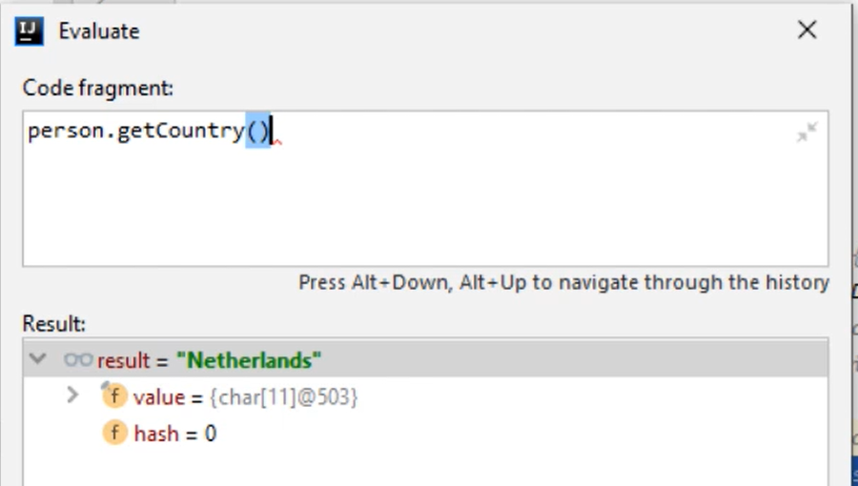

|  |  |
| --- | --- |
| Watch | Evaluate |
| As many expressions as you want | Just one at a time |
| Durable. Throughout the program execution | Just for the moment |
| For example:  Inside loop, we want to trace the value of a variable constantly. |  |

﻿